|  |
| --- |
| 新东方在线英语学习 |
| 新概念 2 册 |
| Lesson85 |



扫一扫。更多有趣的英语资讯。

# Lesson 85 单词讲解

2 headmaster [ˌhed'mɑ:stə] n.校长

3 contribute [kən'tribju:t] v.捐助，援助

4 gift [gift] n.礼物，赠品

5 album ['ælbəm] n.签名簿，相册

6 patience ['peiʃəns] n.耐心

7 encouragement [in'kʌridʒmənt] n.鼓励

8 farewell [feə'wel] n.告别

9 honour ['ɔnə] n.敬意

10 coincidence [kəu'insidəns] n.巧合

11 total ['təutl] n.总数

12 devote [di'vəut] v.致力于

13 gardening ['gɑ:dəniŋ] n.园艺

14 hobby ['hɔbi] n.爱好，嗜好

1. inform v. 告诉，通知

inform sb. sth.

information n. 消息，通知

1. contribute v. 捐助，援助

They contributed food and clothing to the refugees.

1. album n. 签名簿，相册

a photo album 相册

a stamp album 集邮册

1. patience n. 耐心

patient adj. 耐心的 n. 患者，病人

impatient adj. 不耐心的，不耐烦的

1. encouragement n. 鼓励encourage v. 鼓励encourage sb. to do sth.
2. farewell n. 告别

a farewell dinner a farewell party

1. honour n. 敬意

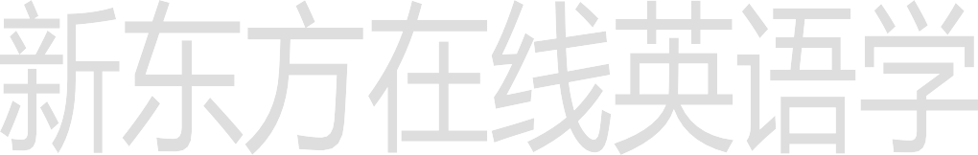

in honour of sb. = in one’s honour

为庆祝，为纪念…

8. devote v. 致力于 奉献

devote oneself to …

I devote myself to（介词） helping the poor.

# Lesson 85 课文&语法讲解

1. I have just received a letter from my old school, informing me that my former headmaster … will be retiring next week.
2. Pupils of the school, …, will be sending him a present to mark the occasion.
3. All those **who have contributed towards the gift** will sign their names in a large album which

will be sent to the headmaster’s home.

All those will sign their names in a large album .

1. We shall all remember Mr. Page for his patience and understanding and for the kindly encouragement he gave us when we went so unwillingly to school.

remember sb. for sth.1

and for sth. 2

We shall all remember Mr. Page for his patience and understanding and for the kindly encouragement he gave us when we went so unwillingly to school.

1. A great many former pupils will be attending a farewell dinner in his honour …
2. It is a curious coincidence that the day before his retirement, Mr. Page will have been teaching for a total of forty years.L43

It is a curious coincidence that the day before his retirement, Mr. Page will have been teaching for a total of forty years.

will have been doing

将来完成进行时

1. … he will devote himself to gardening. devote oneself to doing sth.
2. But this does not matter, for, as he has often remarked, one is never too old to learn.

# Lesson 85 知识拓展

too … to …

too + adj./adv. + to do sth. “太…以至于不能…”

too young to go to school too tired to study

too old to learn

Never too old to learn never too late to apologize

never too late to change your mind never too busy to talk with you

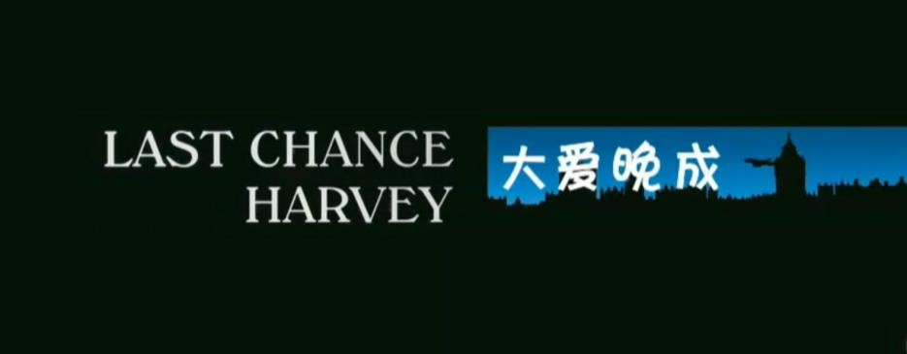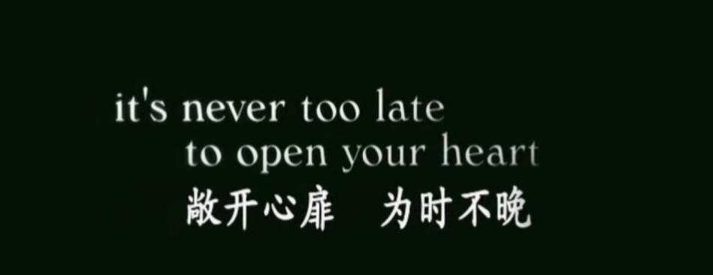

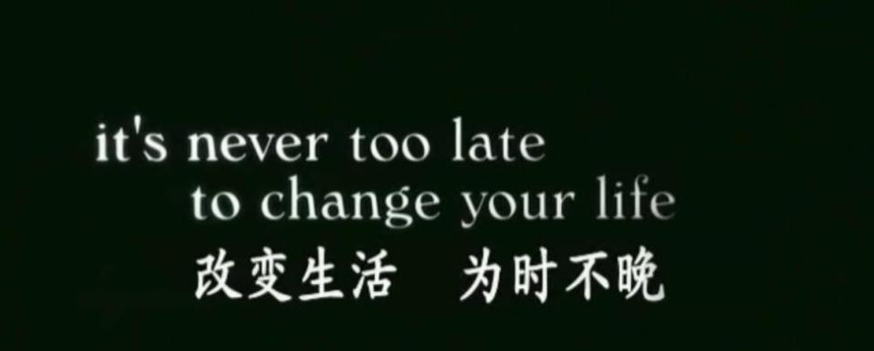

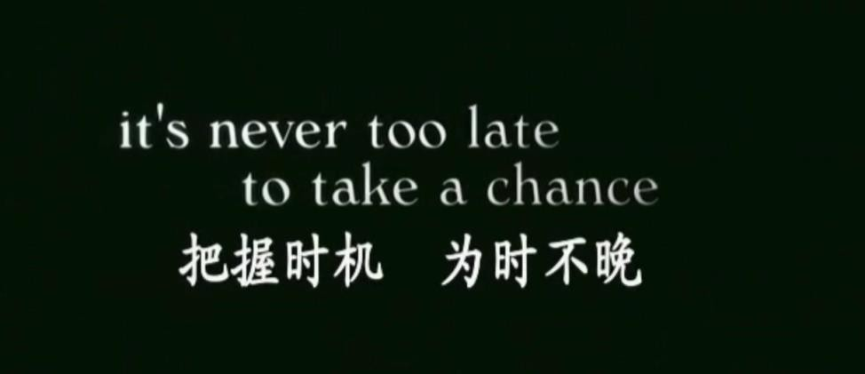

# 看电影 学英语

1. 双语字幕
2. 生活题材
3. 有效的学习步骤：

初看／粗看 （看字幕）

精看 （边查生词，边记录句型）

听看 （不看字幕，只听）

反复看 （内容了解了，反复熟悉）

